Instrument Prepared By Roger W. Knight
Brief Description for Index: Stormwater Covenant
Name of Development: ________
Town of Knightdale Case Number: ________
Parcel Identification Number: ________
REID: ________

Mail After Recording to: ATTN: Town Clerk
Director of Development Services
Town of Knightdale
950 Steeple Square Ct.
Knightdale, NC 27545

STATE OF NORTH CAROLINA
WAKE COUNTY

THE DECLARATION OF MAINTENANCE COVENANT, STORMWATER EASEMENT AND AGREEMENT FOR MAINTENANCE FOR STORMWATER CONTROL FACILITIES
FOR ____________ SUBDIVISION PHASE _____, TOK CASE # _________
Knightdale UDO Sections 9.4

THIS DECLARATION OF MAINTENANCE COVENANT, STORMWATER EASEMENT AND AGREEMENT FOR MAINTENANCE FOR STORMWATER CONTROL FACILITIES is made this ____ day of ___________________, 20___ by and between _________________, a ____________ corporation, whose address is __________________________(hereinafter “Declarant”) and _____________________________, a North Carolina non-profit corporation, whose address is ______________________________ (hereinafter “the Association”) and with, to and for the benefit of the TOWN OF KNIGHTDALE, a political subdivision of the State of North Carolina, whose address is 950 Steeple Square Court, Knightdale N.C. 27545 (hereinafter the “Town”). These parties shall hereinafter sometimes be referred to collectively as the “Parties.”

RECITALS
WHEREAS, the Town, under North Carolina and federal law, is required to regulate the maintenance of Stormwater Control Facilities (as defined herein) constructed to serve new development within the Town's planning jurisdiction to ensure that, following initial construction, the Stormwater Control Facilities are operated, maintained, and, to the extent necessary, repaired in accordance with applicable state and federal law; and

WHEREAS, the Town may be subject to substantial regulatory and financial penalties from the State of North Carolina and the federal government if the above-referenced rules and regulations are not applied to new development occurring within the planning jurisdiction of the Town of Knightdale; and

WHEREAS, the Town Council of the Town has determined that, to maintain the Town’s compliance under applicable state and federal laws, certain obligations are to be met by developers and subsequent owners of Stormwater Control Facilities constructed to benefit Owners of newly created Lots (as defined herein) in new developments; and

WHEREAS, Declarant, as Owner of the Property (which is part or all of the real property described in Book _________, Page __________, Wake County Registry), wishes to develop the Property in accordance with the rules, regulations, and laws of the Town (including conditions of approval as shown in the aforesaid Town of Knightdale Case Number) and the State of North Carolina; and

WHEREAS, the Property is located within the planning jurisdiction of the Town and is subject to certain stormwater quantity and quality requirements set forth in Chapter 9 of the, Knightdale Unified Development Ordinance (the "UDO"), specifically Knightdale UDO Sections 9.4 as may be amended from time to time; and

WHEREAS, Declarant constructed _______________ stormwater control facilities (enter name/number of device) and shall record this easement and maintenance agreement in accordance with Chapter 9 of the UDO; and

WHEREAS, these Stormwater Control Facilities are required to comply with the UDO and that
failure to maintain these Stormwater Control Facilities is a violation of the UDO potentially subjecting each Lot Owner of the Property to significant daily civil penalties and other enforcement actions as and to the extent set forth in the UDO; and

WHEREAS, the applicable sections of the UDO requires that the Declarant grant or dedicate to the Association an access and maintenance easement over and across the Stormwater Areas for the purposes of inspecting and Maintaining the Stormwater Control Facilities set forth in the UDO and this Declaration and Agreement; and

WHEREAS, it is the intention of the Declarant for the Town to have the right and easement to enter upon, over, across and under the Stormwater Areas for the purpose of Inspecting and Maintaining (as defined herein) the Stormwater Control Facilities as and to the extent set forth in this Declaration and Agreement; and

WHEREAS, this Declaration and Agreement has been executed in accordance with the requirements of N.C. General Statutes Chapter 143, Article 21, Part 1, N.C. General Statutes 160D-925, and UDO Section 9.4. Furthermore, in order to comply with the requirements of Section 9.4 of the UDO of the Town of Knightdale, the Parties hereby enter into this Declaration of Maintenance Covenant, Stormwater Easement and Agreement for Maintenance for Stormwater Control Facilities in order to encumber, restrict, and obligate the Owner and any successor Owners of the Property (or any portion thereof) to the terms, conditions, and obligations herein.

NOW THEREFORE, for a valuable consideration, including the benefits the Declarant and the Association may derive therefrom, the receipt of which are hereby acknowledged, the Parties hereby agree as follows:

1. Recitals: The foregoing recitals shall constitute an integral part of this Agreement and are therefore incorporated herein and made a part hereof.

2. Responsibility to Install (Declarant): The Declarant shall install the stormwater control facilities pursuant to Town design standards and subject to the approval of the Town. The stormwater control facilities shall serve all of the Lots in Phase _____, of the ____________ development, as recorded in and on Book of Maps _______, Pages ______. The Declarant shall be responsible for the construction of the Stormwater Control Facility and appurtenances in the manner specified herein and in strict compliance with the approved Construction Drawings.

3. Responsibility to Grant Easement (Declarant): The Declarant shall grant or dedicate to the Town an access and maintenance easement over and across the Stormwater Areas for the purposes of inspecting and Maintaining the Stormwater Control Facilities set forth in the UDO and this Declaration and Agreement. The SCM Access & Maintenance Easement is identified on the plat recorded in and on Book of Maps ______, Page ______, Wake County Registry (Exhibit A).

4. Responsibility to Repair and Maintain (Association): The Association shall operate, maintain and repair the Stormwater Control Facilities. This Agreement shall not obligate the Town of Knightdale to maintain or repair any structural Stormwater Control Facilities, and the Town of Knightdale shall not be liable to any person for the condition or operation of structural Stormwater control facilities. This agreement grants to the Town of Knightdale a right of entry to inspect, monitor, maintain, repair, and reconstruct Stormwater Control Facilities. This Agreement shall not in any way diminish, limit, or restrict the right of the Town of Knightdale to enforce any of its ordinances as authorized by law. The Town has the right to recover from the Association and its members any and all costs the Town expends to maintain or repair the structural Stormwater Control Facilities or to correct any operational deficiencies. Failure to pay the Town all of its expended costs, after 45 days written notice, shall constitute a breach of this Agreement. The Town shall thereafter be entitled to bring an action against the Association and its members to pay, or foreclose upon the lien hereby authorized by the Agreement against the property, or both, in case of a deficiency. Interest, collection costs, and attorney fees shall be added to the recovery;

5. Responsibility for a Stormwater Operations and Maintenance Manual (Declarant): The Declarant shall be responsible for the construction of the Stormwater Control Facility and appurtenances in the manner specified herein and in strict compliance with the Stormwater Operations and Maintenance Manual (Exhibit B). The Declarant shall be responsible for submitting an Annual Maintenance Inspection Report in accordance with the Town’s submittal requirements and schedule (Exhibit C & D), and any penalties related to the failure to comply therewith, as set forth in Exhibit E.

6. Agreement Binding on Successors and Running with the Land: The covenants agreed to and the terms, conditions, obligations and restrictions imposed herein shall be binding upon the Declarant, the Association, their successors and assigns, and shall continue as a servitude running with the land in perpetuity. Declarant covenants that as of the date of this Agreement, it is vested of the Property in fee simple and has the right to convey the easements and rights contained in this Declaration and Agreement.

7. Reliance and Indemnification: Declarant acknowledges that the Town is acting in reliance on Declarant's authority to enter into this Declaration and Agreement and the terms, conditions, obligations, and restrictions imposed herein in its authorization to subdivide the Property and in the issuance of any permits or development approvals associated with any construction of improvements on the Property and that the Town may suffer irreparable harm from the violation of the covenants, restrictions, and obligations established herein. Based upon the obligations of the Declarant and the Association, both Declarant and Association agree to fully indemnify the Town for any and all damages, including costs and attorneys’ fees, for any failure of the Declarant or the Association, respectively, to fulfill their respective obligations in and under this Agreement.

8. Choice of Law and Jurisdiction: The Parties hereto agree that this Agreement shall be construed under the laws of the State of North Carolina and that each is subject to the jurisdiction of the State of North Carolina and that Wake County is the proper venue for any action or dispute arising from this Agreement.

THE REMAINDER OF THIS PAGE INTENTIONALLY BLANK
SIGNATURE AND ACKNOWLEDGMENT PAGES FOLLOW

[Declarant Signature Page]
IN WITNESS WHEREOF, Declarant hereby executes this Declaration and Agreement under
seal as of the day and year first below written.

DECLARANT:

_____________________________
Signature

Company:
Title:
Name (print):

WAKE COUNTY, NORTH CAROLINA
I certify that the following person(s) personally appeared before me this day, each acknowledging to me that he or she signed the foregoing document: _______________________.

Date: ____________ ______, 20____ _____________________________________________
[Notary's signature as name appears on seal]

_________________________________, Notary Public
[Notary's printed name as name appears on seal]

My commission expires: ___________ ______, 20_____
[Affix Official Seal]

[Association Signature Page]

IN WITNESS WHEREOF, the Association hereby executes this Declaration and Agreement under seal as of the day and year first below written.

ASSOCIATION:

__________________________________
Signature

Association Name:
Title:
Name (print):

WAKE COUNTY, NORTH CAROLINA
I certify that the following person(s) personally appeared before me this day, each acknowledging to me that he or she signed the foregoing document: _____________________________.

Date: ____________ ______, 20____ _____________________________________________
[Notary's signature as name appears on seal]

_________________________________, Notary Public
[Notary's printed name as name appears on seal]

My commission expires: ___________ ______, 20_____
[Affix Official Seal]

[Town Signature Page]
IN WITNESS WHEREOF, the Town hereby executes this Declaration and Agreement under seal as of the day and year first below written.
TOWN OF KNIGHTDALE:
__________________________________
Signature

Title: Assistant Town Manager
Name (print):

WAKE COUNTY, NORTH CAROLINA
I certify that the following person(s) personally appeared before me this day, each acknowledging to me that he or she signed the foregoing document: _____________________________.

Date: ____________ ______, 20____ _____________________________________________
[Notary's signature as name appears on seal]

_________________________________, Notary Public
[Notary's printed name as name appears on seal]

My commission expires: ___________ ______, 20_____
[Affix Official Seal]

Exhibit A
Description of Stormwater Control Facilities and Drainage Easements

See items labeled as “_______” and “SCM Maintenance and Access Easement,” as recorded in “________ Plat for ___________”.

Book of Maps ______, Page _____ through Page _____, Wake County Registry.

Exhibit B
Stormwater Operations and Maintenance Manual
(If recording more than one SCM type, combine all Maintenance Manual pages here with headings to identify which SCM facility type they pertain to)

Exhibit C
Annual Inspection Submittal Requirements
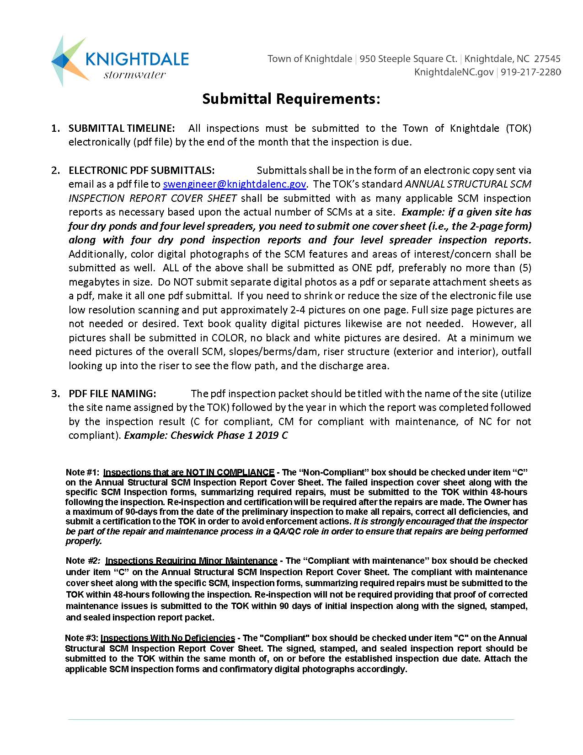
Exhibit D
Inspection Schedule

90 Day Inspection Cycle
60 Days
30 Days
The inspection due date is determined by the month of initial certification.
This facility inspection will be due every year after certification.

E

Exhibit E
Penalty for Non-compliance

Notice to Comply – A notice to comply shall be issued to any facility owner who has not submitted an inspection form, or an updated inspection form by the 60-day maintenance period. A notice to comply provides the operator with a 14-day window to complete any prescribed maintenance and submit a new inspection form before a violation is issued.

Notice of Violation – A notice of violation shall be issued to any facility owner who does not complete the corrective actions listed on the notice to comply, or in situations of severe noncompliance or failure. Once a Notice of Violation is issued, there shall be a fee of $250 issued with an additional $250 per day thereafter until the violation is corrected.

For more information regarding the penalty process, please refer to Section 6.4 of the Town of Knightdale UDO.

