Exhibit B
Stormwater Operations and Maintenance Manual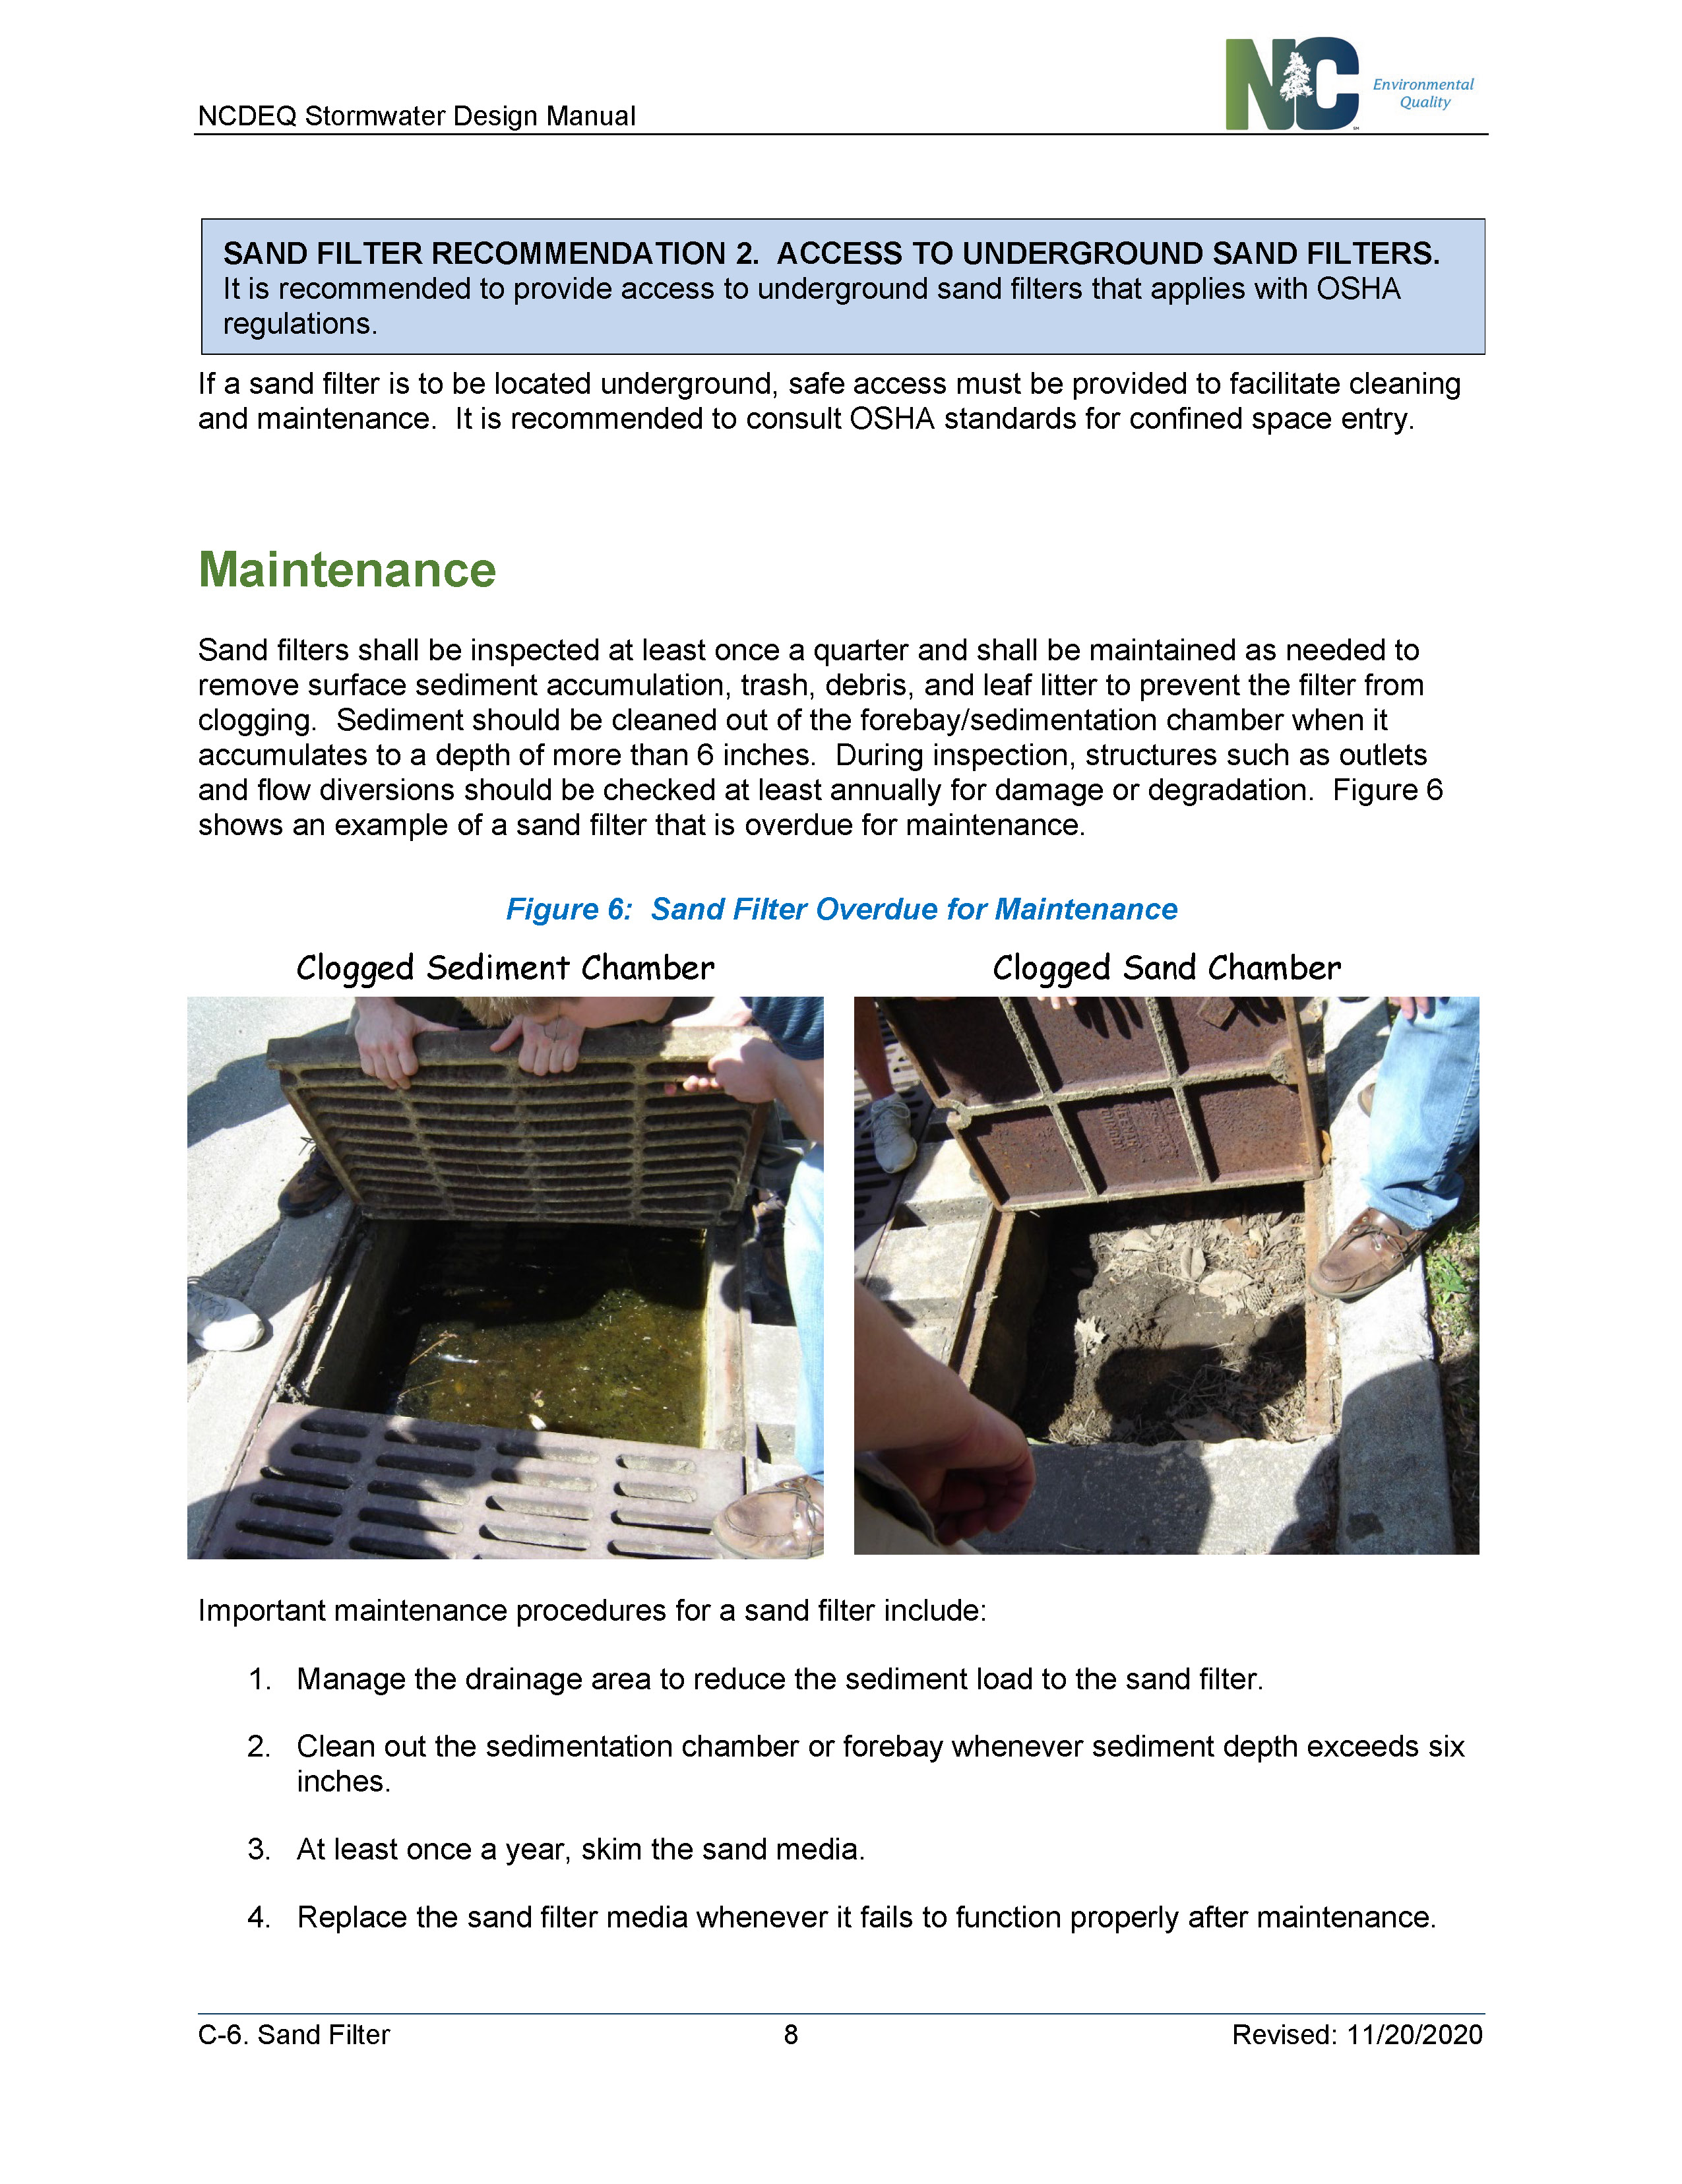
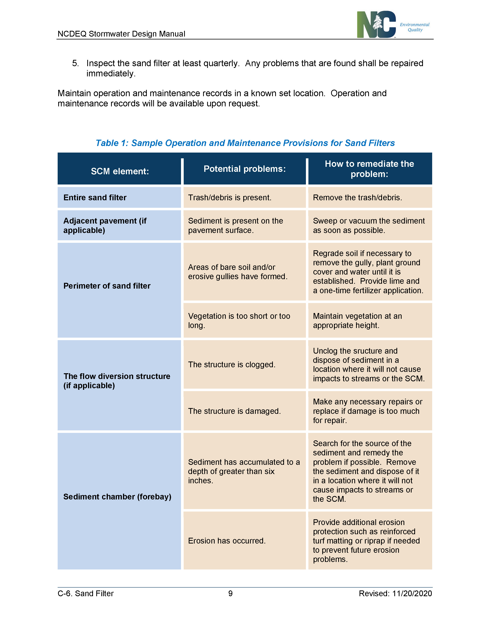

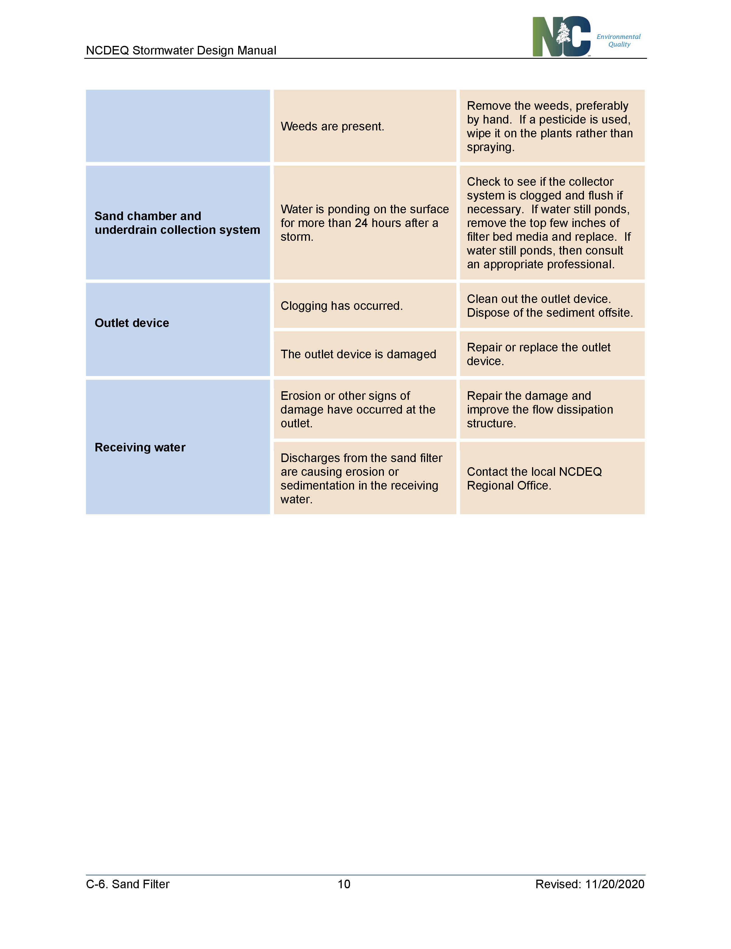

Exhibit C
Annual Inspection Submittal Requirements
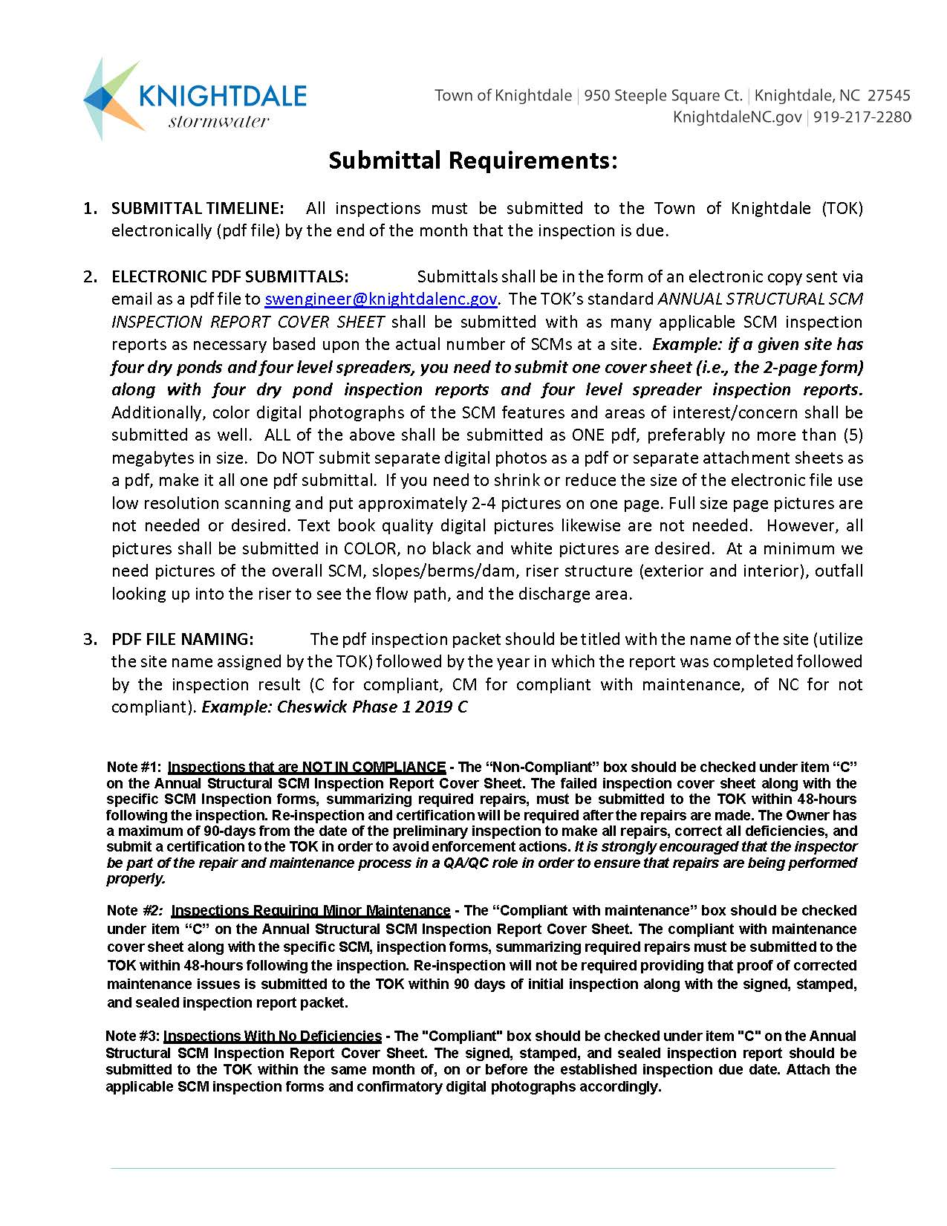
Exhibit D
Inspection Schedule

90 Day Inspection Cycle
60 Days
30 Days
The inspection due date is determined by the month of initial certification.
This facility inspection will be due every year after certification.

E

Exhibit E
Penalty for Non-compliance

Notice to Comply – A notice to comply shall be issued to any facility owner who has not submitted an inspection form, or an updated inspection form by the 60-day maintenance period. A notice to comply provides the operator with a 14-day window to complete any prescribed maintenance and submit a new inspection form before a violation is issued.

Notice of Violation – A notice of violation shall be issued to any facility owner who does not complete the corrective actions listed on the notice to comply, or in situations of severe noncompliance or failure. Once a Notice of Violation is issued, there shall be a fee of $250 issued with an additional $250 per day thereafter until the violation is corrected.

For more information regarding the penalty process, please refer to Section 6.4 of the Town of Knightdale UDO.

